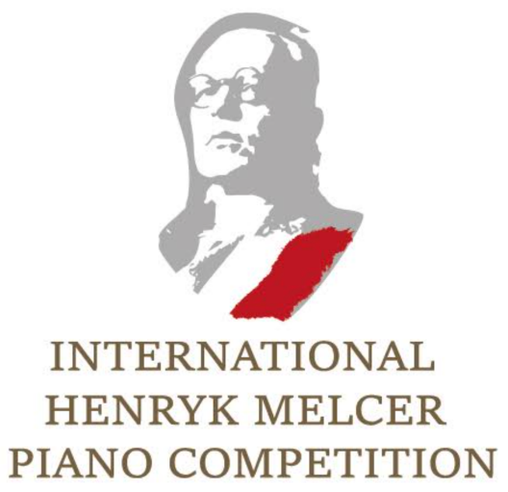
The 1st International Henryk Melcer Piano Competition
Competition Rules

1. The Competition is opened to pianists of all ages and nationalities.
2. The main goal of the competition is to promote Henryk Melcer - pianist, composer and teacher, who was one of the most talented and admired musicians during his lifetime, to be hurriedly forgotten after his death. Henryk Melcer educated many composers and pianists and was a jury member at the first Fryderyk Chopin International Piano Competition.
3. The Competition takes place in form of video submission. The performance will be judged according to the participant’s performance skills, musical sense and the overall performance.
4. The Competition is organized by Calisia Arts Foundation.
5. The Competition will be devided in the following age categories:
CATEGORY | AGE | TIMING | APPLICATION  FEE
A | born in 2013 and after | max. 8 min. | 50 EUR
B | born in 2009 and after | max. 12 min. | 50 EUR
C | born in 2006 and after | max. 16 min. | 50 EUR
D | born in 2003 and after | max. 20 min. | 50 EUR
E | no age limits | max. 30 min. | 70 EUR

6. Program of contestant’s competition performance is free of choice. However the competition committee encourages all participants to involve Henryk Melcer's pieces in their competition program. A special 'Melcer' prize will be awarded for the best interpretation of Henryk Melcer's piece.
7. The non refundable application fee should be paid by the bank transfer. Competition participants are asked to enter in transfer’s description (in following order): The 1st Henryk Melcer International Piano Competition, Name, Surname, Category.
Account number for payments in PLN: 57160014621808126950000001
Account number for payments in EUR: PL03 1600 1462 1808 1269 5000 0003
SWIFT code – PPABPLPKXXX
8. Following prizes will be awarded:
CATEGORY | A | B | C | D | E
I Prize | diploma, medal and concert invitation | diploma, medal and concert invitation | diploma, medal and concert invitation | cash prize, diploma, medal and concert invitation | cash prize, diploma, medal and concert invitation
II Prize | diploma  and  concert invitation | diploma and  concert invitation | diploma and concert invitation | cash prize, diploma and concert invitation | cash prize, diploma and concert invitation
III Prize | diploma | diploma | diploma | cash prize, diploma and concert invitation | cash prize, diploma and concert invitation
Distinction | diploma | diploma | diploma | diploma | diploma

9. Prizes totaling EUR 2000 will be awarded in groups D and E. Moreover selected participants in all age categories will be invited to perform in prestigious concert halls in Poland and Austria. The exact distribution of the monetary prizes and concert invitations is the responsibility of the jury and will be decided in a final jury meeting. The jury reserves the right not to award prizes.
10. All competitors can enroll in higher categories, if they consider themselves able.
11. Performing competition repertoire by heart is not strictly necessary in all age categories.
12. In order to receive money prizes, prizewinners are obligated to participate in designated by the organizer of the competition prizewinners’ concert.
13. Candidates wishing to enter the Competition will have to submit the required application documents by email.
14. Complete application must include:
a) scan of the application form available on the Competition’s website - correctly completed and personally signed by the candidate for the Competition
b) short biographical note
c) photocopy of an official document indicating date of birth
d) one current photo
e) Youtube link to the video recording containing repertoire prepared for the Competition, sent in an e-mail with other application materials
f) proof of payment of the application fee. The candidate’s name and the purpose of the payment should be indicated in transfer’s description
15. Video recording requirements:
a) the video image must show the pianist’s hands while playing and the right side of his/her whole figure, filmed with one camera without cuts during the performance of a single piece
b) Any kind of editing or manipulation of the audio and video is forbidden
c) It is allowed to divide the program’s execution into several videos and then merge them in
one single video, otherwise it can be recorded entirely without cuts between the pieces
d) Every video must be recent and recorded in last 2 years
e) The video must be uploaded on YouTube/YouKu platform with the title: “1st International Henryk Melcer Piano Competition” – NAME, SURNAME, CATEGORY. The competitor shall write the program performed in the description of the video.
f) By submitting the application materials, competitor automatically authorize competition organizers to use his/her video for the purposes related to the competition - sending the videos to the judges, publishing the videos on the website and on social channels ect.
16. Deadline for submitting application - 31.03.2023.
17. The Competition Committee reserves the right to make any changes to the present rules.
By applying to the competition, each participant confirms the unconditional acceptance of the rules/regulations and authorizes the Committee to publish names, surnames and videos of the competitors (including underages’ videos).
18. The judges' decision is final in all matters relating to the competition.
19. In case of doubt the Polish language version of the Rules will be used in interpreting and clarifying their provisions.

